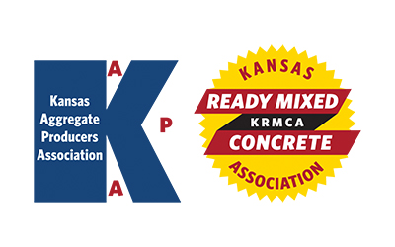
KAPA Research & Specifications (R&S)
KRMCA Technical and Quality Control (TQC)
Quarterly Committee Meeting
Monday – May 8, 2023 - 1:30 PM
AGENDA

- Introductions
- Antitrust Statement / Approval of February 2, 2023 R&S/TQC Minutes

Follow-up from previous meetings(s)
- Concrete testing oversight program – updates from KDOT

- New KDOT protocol for addressing low strength test results – update from KDOT

- KDOT Quarry Road Reimbursement Policy – update from KDOT

- Fly ash availability
- Ready mix producers are already experiencing issues
- One traditional source (power plant) is unavailable
- Because of these early issues, market is likely to be stressed all year. Options?

New Items
- Condition assessment of those pavements built in the first three years of KTMR-22 spec.

