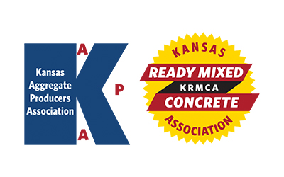
KAPA Research & Specifications (R&S)
KRMCA Technical and Quality Control (TQC)
Quarterly Committee Meeting
Tuesday – January 30, 2024 - 1:30 PM
AGENDA

1. Introductions

2. Antitrust Statement

3. Review and Approval of 10/31/23 R&S/TQC Meeting Minutes

Business from Previous Meetings

4. KDOT Concrete Testing Oversight Program. Staffing and organizational configuration? Anticipated “live” date? Engagement with KRMCA for process development.

5. Progress update from KDOT on new protocols for addressing low strength test results?

6. KDOT resistivity testing for concrete. Update from KDOT of data collected from districts and any potential changes to specs/practices?

New Business

7. Update from KDOT on the KDOT/KSU/KU research project associated with determining unique aggregate identifiers. Have the four quarries been selected?

8. E-ticketing Update from KDOT

9. KDOT has apparently drawn some conclusions from their testing of portland limestone cement from different producers. Can/will KDOT share their findings with those individual cement producers and KRMCA membership?

10. KDOT had previously stated that they will begin a review and rewrite of the General Concrete spec. The current section that specifically addresses required compressive strength and the process to use historical data to accept lower strength test results probably warrants some discussion. Are there concerns with the current language and its interpretation and application by both producers and KDOT?

11. What percentage of 2024 KDOT construction projects will utilize contract inspectors?

