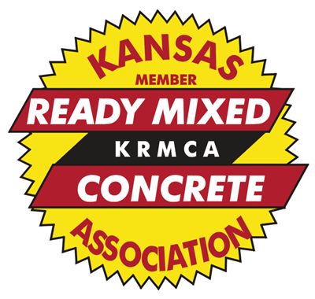

2023 KRMCA Mixer Driver of the Year &
Rookie of the Year Award
(NOTE: For Rookie of the Year Entries, the driver must have driven for at least one year, but no more than two years by September 30, 2023)

Objective: This award recognizes and acknowledges the outstanding mixer driver in our membership for the 12-month period October 1, 2022 through September 30, 2023. The winner will be announced during the annual KRMCA Convention to be held January 10-12, 2024.

How many drivers may I nominate? Each member company may submit one nominee for each category (Driver of the Year and Rookie of the Year). This nomination may include a hired driver.

The Award: The winning drivers will be introduced and honored at the KAPA-KRMCA Joint Annual Convention. He/She will receive:
- $250 cash award
- Invitation to the KAPA-KRMCA Joint convention, room and meals paid by KRMCA.
- Plaque for driver
- Plaque for driver’s company

Mixer Driver Qualifications:
- Must be a ready mixed concrete truck driver (mixer truck only). May be a contract driver. Must have driven as a full-time ready-mix driver.
- Perfect attendance for the period in question (no un-excused absences)
- No “at fault” accidents
- No “out of service violations” on truck inspections
- Good “driver safety” attitude
- Keeps his/her truck clean
- Community service (to be used as a tie breaker)

What to do and When?
- Obtain and review prospective nominee’s MVR.
- Complete the nomination form (Be Sure to Include Picture of Driver with his/her Truck)
- Return the completed form and packet to KRMCA by October 31, 2023

NOMINATION FORM ON BACK

